**CDP**

Trifork's CDP score can be found here: <https://www.cdp.net/en/data/scores?cid=9205306762&adgpid=95799580520&itemid=&targid=kwd-1490162750764&mt=p&loc=1005010&ntwk=g&dev=c&dmod=&adp=&gad_source=1&gad_campaignid=9205306762&gbraid=0AAAAADjPEpIjzMgn1ICsvt13YYJj9xKar&gclid=Cj0KCQjwlMfABhCWARIsADGXdy_hIrLFdY1DKUyhzoeyCbrnbJoG9GocD7QMabqkF3bOxxcYcx0e8cMaAuAIEALw_wcB>

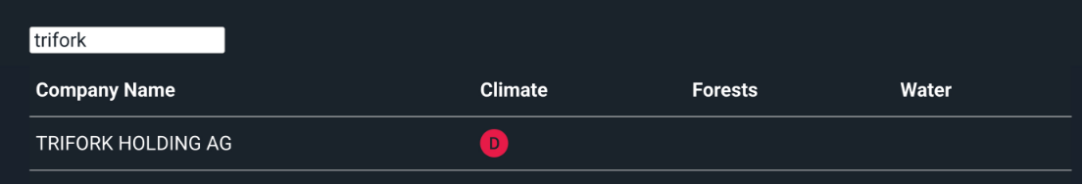

Trifork Group report yearly ESG data on CDP. A business partner can apply for our data on the platform, then the ESG team will provide them access.