**SBTi**

Trifork Group has committed to Science Based Targets initiative in 2023 and will send our climate reduction targets for approval latest in October 2025. Trifork Group has committed to set near-term GHG reduction targets in line with the Paris Agreement.

Trifork Group's commitment can be found here: <https://sciencebasedtargets.org/target-dashboard>

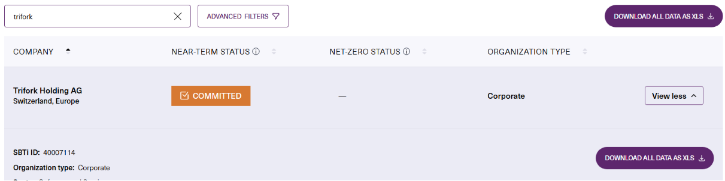

More information can be found on our website: <https://trifork.com/2024/01/trifork-holding-ag-commits-to-science-based-targets-initiative-2/>